REPORT

Challenges Faced During the Project

TASK-1 :Pull docker image with SQL environment
During TASK-1

- I faced difficulty in setting up the Docker container with the MySQL image.
- I Used command prompt to check the docker version and verify the MYSQL images.
- The Docker Desktop image took time to reflect in the application.
- In the end, I created a folder and saved the MYSQL environment credentials in notepad file.

Task 2: Perform the Problem Queries - challenges faced
During TASK-2
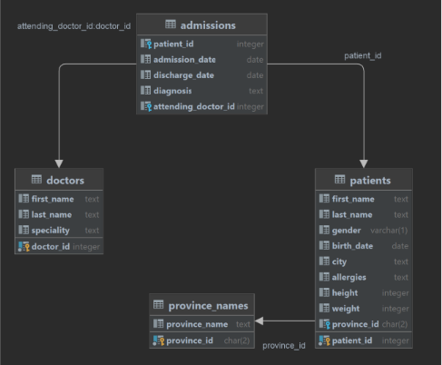

- While Connecting the database server, I faced issues because it kept showing “access denied” error. even though all the credentials were given correctly.
- Understanding the database, how the tables were linked and which columns are similar in each of it.
- Got errors like wrong column name, syntax mistakes, Finding these mistakes and correcting them took time.

